Capacity vs. CCA
Starter batteries have two distinct values, CCA and capacity.These two readings are close to each other like lips and teeth, but the characteristics are uniquely different; one cannot predict the other. [BU-806, Changes in Capacity and Resistance]
Measuring the internal battery resistance, which relates to CCA on a starter battery, is relatively simple but the reading provides only a snapshot of the battery at time of measurement. Resistance alone cannot predict the end of life of a battery. For example, at a CCA of 560A and a capacity of 25 percent, a starter battery will still crank well but it can surprise the motorist with a sudden failure of not turning the engine (as I have experienced).
The leading health indicator of a battery is capacity,but this estimation is difficult to read. A capacity test by discharge is not practical with starter batteries; this would cause undue stress and take a day to complete. Most battery testers do not measure capacity but look at the internal resistance, which is an approximation of CCA. The term approximationis correct — laboratory tests at Cadex and at a German luxury car manufacturer reveal that the readings are only about 70 percent accurate. A full CCA test is seldom done; one battery can take a week to measure.
The SAE J537 CCA test mandates to cool a fully charged battery to -18°C (0°F) for 24 hours, and while at subfreezing temperature apply a high-current discharge that simulates the cranking of an engine. A 500 CCA battery would need to supply 500A for 30 seconds and stay above 7.2V (1.2V/cell) to pass. If it fails the test, the battery has a CCA rating of less than 500A. To find the CCA rating, the test must be repeated several times with different current settings to find the triggering point when the battery passes through 7.2V line. Between each test, the battery must be brought to ambient temperature for recharging and cooled again for testing. (For CCA DIN and IEC norms, please refer to “Test Method” on this essay.)
To examine the relationship between CCA and capacity, Cadex measured CCA and capacity of 175 starter batteries at various performance levels. Figure 2 shows the CCA on the vertical y-axis and reserve capacity* readings on the horizontal x-axis. The batteries are arranged from low to high, and the values are given as a percentage of the original ratings.
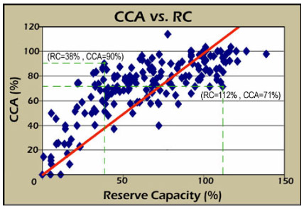 | Figure 2: CCA and reserve capacity (RC) of 175 aging starter batteries  The CCA of aging starter batteries gravitates above the diagonal reference line. (Few batteries have low CCA and  high capacity.)  Courtesy of Cadex
Test method: The CCA and RC readings were obtained according to SAE J537 standards (BCI). CCA (BCI) loads a fully charged battery at –18°C (0°F) for 30s at the CCA-rated current of the battery. The voltage must stay above 7.2V to pass. CCA DIN and IEC are similar with these differences: DIN discharges for 30s to 9V, and 150s to 6V; IEC discharges for 60s to 8.4V. RC applies a 25A discharge to 1.75V/cell and measures the elapsed time in minutes.
The table shows noticeable discrepancies between CCA and capacity, and there is little correlation between these readings. Rather than converging along the diagonal reference line, CCA and RC wander off in both directions and resemble the stars in a clear sky. A closer look reveals that CCA gravitates above the reference line, leaving the lower right vacant. High CCA with low capacity is common, however, low CCA with high capacity is rare. In our table, one battery has 90 percent CCA and produces a low 38 percent capacity; another delivers 71 percent CCA and delivers a whopping 112 percent capacity (these are indicated by the dotted lines).
As discussed earlier, a battery check must include several test points. An analogy can be made with a medical doctor who examines a patient with several instruments to find the diagnosis. A serious illness could escape the doctor’s watchful eyes if only blood pressure or temperature was taken. While medical staff are well trained to evaluate multiple data points, most battery personnel do not have the knowledge to read a Nyquist plot and other data on a battery scan. Nor are test devices available that give reliable diagnosis of all battery ills.

* North America marks the reserve capacity (RC) of starter batteries in minutes; RC applies a 25A discharge to 1.75V/cell and measures the elapsed time in minutes. Europe and other parts of the world use ampere/hours (Ah). The RC to Ah conversion formula is as follows: RC divided by 2 plus 16.

